Ideation Phase

Define the Problem Statements

|  |  |
| --- | --- |
| Date | 26 June 2025 |
| Team ID | LTVIP2025TMID34546 |
| Project Name | Pattern sense:Classifying Fabric Patterns using Deep Learning |
| Maximum Marks | 2 Marks |

**Customer Problem Statement Template:**

Create a problem statement to understand your customer's point of view. The Customer Problem Statement template helps you focus on what matters to create experiences people will love.

A well-articulated customer problem statement allows you and your team to find the ideal solution for the challenges your customers face. Throughout the process, you’ll also be able to empathize with your customers, which helps you better understand how they perceive your product or service.

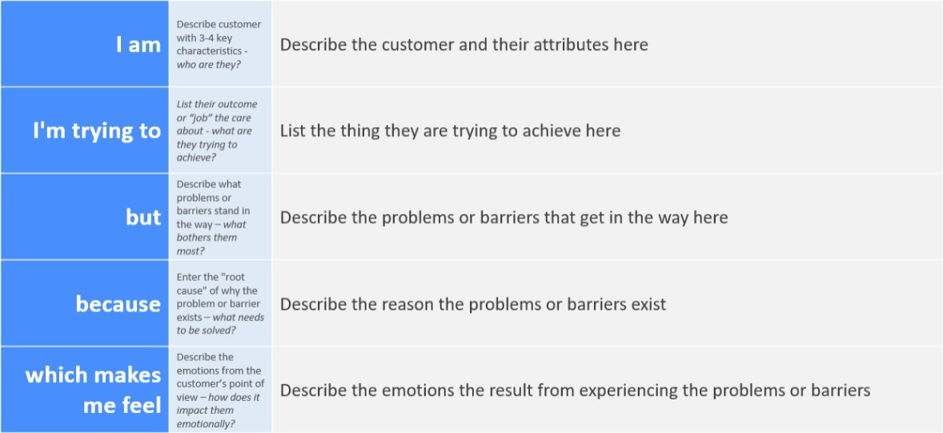

Reference: <https://miro.com/templates/customer-problem-statement/>

**Example:**

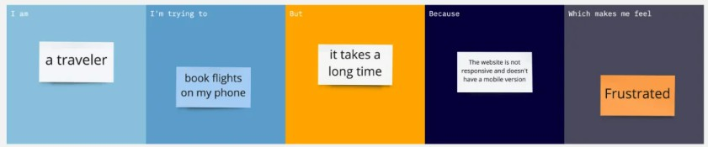

|  |  |  |  |  |  |
| --- | --- | --- | --- | --- | --- |
| **Problem**  **Statement (PS)** | **I am (Customer)** | **I’m trying to** | **But** | **Because** | **Which makes me feel** |
| PS-1 | a fashion designer | identify suitable fabric  patterns quickly | manual  sorting is time-cons uming  and error-pro ne | there is no automated system for accurate  classification | frustrated and delayed |
| PS-2 | a textile researcher | analyze fabric types for research | existing datasets are  unorganiz ed | classification methods are not standardized | inefficient and confused |